Day 1

EID MVSNARAV

NAME: Aravind Kasanagotuu

**Q1: WHAT IS SDLC ?**

SDLC stands for Software Development Life Cycle. It is a step-by-step process used to design, develop, test, and maintain software. The main goal of SDLC is to produce high-quality software that meets user requirements within time and budget.

**Q2 WHY SDLC ?**

**SDLC (Software Development Life Cycle)** is a structured process used to develop software efficiently and with high quality. It provides a step-by-step plan including phases like requirement analysis, design, coding, testing, and maintenance. SDLC helps in reducing project risks and ensuring successful software delivery. It also improves planning, scheduling, and management of the software process. Overall, SDLC ensures that the final product meets user needs and works effectively.

**Q3 WHAT IS THE STEPS OF SDLC ?**

Requirement Gathering – Understanding what the users need.

System Design – Planning how the software will work.

Implementation (Coding) Writing the actual code for the software.

Testing – Checking the software for errors or bugs.

Deployment – Releasing the software to the users.

Maintenance – Fixing issues and updating the software after release.

**Q4 WHAT IS THE MODELS OF SDLC ?**

**Agile Model** – An adaptive, flexible model that delivers working software in small, fast cycles with continuous feedback.

**Waterfall Model** – A linear and sequential model where each phase must be completed before the next starts.  
**V-Model (Verification and Validation)** – Like Waterfall but with testing planned alongside   
**Incremental Model** – Software is developed and delivered in small, workable parts (increments).  
**Iterative Model** – The software is developed through repeated cycles, improving with each version.  
**Spiral Model** – Focuses on risk analysis and combines iterative development with systematic steps.  
**Big Bang Model** – Development starts with little planning and all coding is done randomly until the product evolves.

**Q5 WHAT ARE THE DIFFERENT TYPES OF NETWORKS ?**

PAN (Personal Area Network) – Connects personal devices (like phone, laptop, smartwatch) over a short range, usually within a few meters.

LAN (Local Area Network) – Connects computers and devices in a small area such as a home, school, or office for resource sharing.

WAN (Wide Area Network) – Connects computers over large distances, often globally; the Internet is the largest WAN.

WLAN (Wireless Local Area Network) – A LAN that uses wireless signals (Wi-Fi) instead of cables.

**Q6 WHAT ARE THE TYPES OF SERVERS ?**

Web Server – Hosts websites and delivers web pages to users over HTTP/HTTPS.

File Server – Stores and manages files so users on a network can access and share them.

Database Server – Provides database services and handles data storage, queries, and management

Mail Server – Sends, receives, and stores emails for users

**DNS Server** – Translates domain names into IP addresses so browsers can load websites.

**Q7 DNS**

**DNS (Domain Name System)** is a system that translates human-readable domain names like www.123.COM into IP addresses like machine readable address.

**Q8 WHAT IS TCP AND UDP AND WHAT IS THE DIFFERENCE ?**

**TCP (Transmission Control Protocol)** is a connection-oriented protocol that ensures reliable and ordered data delivery with error checking.  
**UDP (User Datagram Protocol)** is a connectionless protocol that sends data without guarantee of delivery or order, but is much faster.

The main difference is that **TCP is reliable but slower**, used in applications like web browsing and email, while **UDP is faster but unreliable**, suitable for video streaming and gaming.

**Q9 WHAT YOU KNOW ABOUT MAC ADDRESS ? WHAT IS DIFFERENCE BETWEEN MAC ADDRESS AND IP ADDRESS ?**

A **MAC (Media Access Control) address** is a unique hardware identifier assigned to a device's network interface card (NIC). It is a 48-bit address, usually written in hexadecimal format **(e.g., 00:1A:2B:3C:4D:5E),** and is used for communication within a local network (LAN).

An **IP (Internet Protocol) address** is a logical address assigned to a device on a network to identify it globally on the internet. It can change over time or based on the network.

The key difference is that **MAC address is permanent and physical**, while **IP address is temporary and logical**. MAC works at the data link layer, and IP works at the network layer.

**Q10 WHAT IS OSI MODEL?**

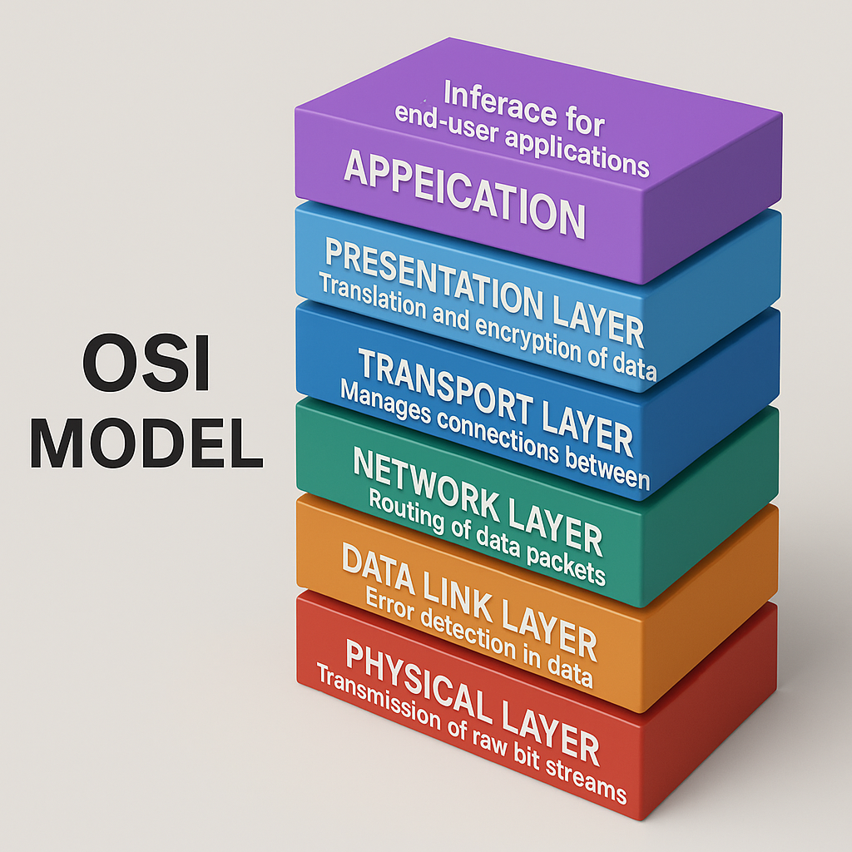

The **OSI Model (Open Systems Interconnection Model)** is a conceptual framework used to understand and standardize how different networking systems communicate over a network.

It has **7 layers**, each with a specific function:

**Application Layer** – Provides services to the user (e.g., web browsers, email).

**Presentation Layer** – Translates, encrypts, and compresses data.

**Session Layer** – Manages connections between devices.

**Transport Layer** – Ensures reliable data delivery.

**Network Layer** – Handles routing and logical addressing.

**Data Link Layer** – Ensures error-free transfer between devices on the same network.

**Physical Layer** – Deals with the physical transmission of data (cables, signals).

**Q11 WHAT IS AN IPV4 ADDRESS ? WHAT ARE THE DIFFERENT CLASSES OF IPV4 ?**

**IPv4 (Internet Protocol version 4)** is a 32-bit address used to identify devices in a network. It is written in dotted decimal format (e.g., 192.168.1.1) and is the most commonly used IP version.

IPv4 helps in proper communication and data transfer between devices in a network

There are five classes of IPv4 addresses:

**Class A**: Used for very large networks

**Class B**: Used for medium-sized networks

**Class C**: Used for small networks

**Class D**: Used for multicast communication

**Class E**: Reserved for research and experimental use

**Q12 WHAT IS THE ADVANTAGES OF VPN ?**

**Advantages of VPN**:

**Privacy and Security** – A VPN encrypts your internet connection, keeping your data safe from hackers, especially on public Wi-Fi.

**Access Restricted Content** – It allows you to bypass geographic restrictions and access websites or services blocked in your region.

**Q13. TYPES OF VPN AND EXPLAIN (ACCESS,SITE TO SITE,INTRANET,EXTRANET) VPN**

**Access VPN** :allows individual users to securely connect to a private network over the internet from a remote location.  
It is commonly used by remote workers to access their company's internal systems safely.

**Site-to-Site VPN:** Securely connects two or more entire networks across different locations, enabling seamless resource sharing as if they were one network. This creates a persistent, encrypted tunnel between sites.

**Intranet VPN:** Provides secure remote access for authorized employees to a company's internal network (intranet) from outside the office. Users connect via VPN clients to access internal resources as if they were on-site.

**Extranet VPN:** Extends a company's intranet to specific external partners (customers, suppliers) with controlled access to designated resources. This facilitates secure collaboration and data exchange for business purposes.

**Q14.WHAT IS NODE AND LINK ?**

A **node** is any device in a network that can send, receive, or forward data.  
Examples include computers, routers, switches, and printers.

A **link** is the physical or logical connection between two nodes that allows data to travel.  
It can be wired (like Ethernet cables) or wireless (like Wi-Fi or Bluetooth).

**Q15.TOPOLOGY MEANS ?**

**Topology** in computer networks refers to the **arrangement or layout of devices (nodes) and connections (links)** in a network.  
It defines how computers, cables, and other devices are physically or logically connected to each other.

**Q16 DIFFERENT TYPES OF NETWORK TOPOLOGY ?**

**Bus Topology –** All devices are connected to a single central cable; easy but less reliable.

**Star Topology –** All devices connect to a central hub or switch; easy to manage and widely used.

**Ring Topology** – Devices are connected in a circular loop; data travels in one direction.

**Mesh Topology –** Every device connects to every other device; very reliable but costly.

**Tree Topology –** A mix of star and bus topologies; used in large networks.

**Hybrid Topology –** A combination of two or more topologies to suit complex network needs.

**Q17 WHAT IS EXTENDED BUD TOPOLOGY ? IS TREE TOPOLOGY?**

**YES!**

**Q18 what is use of router and how is it different from gateway ?**

A **router** is a networking device that connects multiple networks and directs data between them.  
It chooses the best path for data to travel from one network to another, such as from your home network to the internet.

A **gateway** connects **different types of networks,** often translating between different protocols or architectures.

**Router** connects similar networks **Gateway** connects different networks

**Q19SMTP**

**SMTP (Simple Mail Transfer Protocol)**

Client – This is your device (like a laptop or phone) where you write and send an email.

SMTP Server – It takes your email and decides where to send it.

Mail Server – The server that receives and stores the email for the recipient.

Outgoing Mail – The message travels from your device, through the SMTP server, to the mail server.

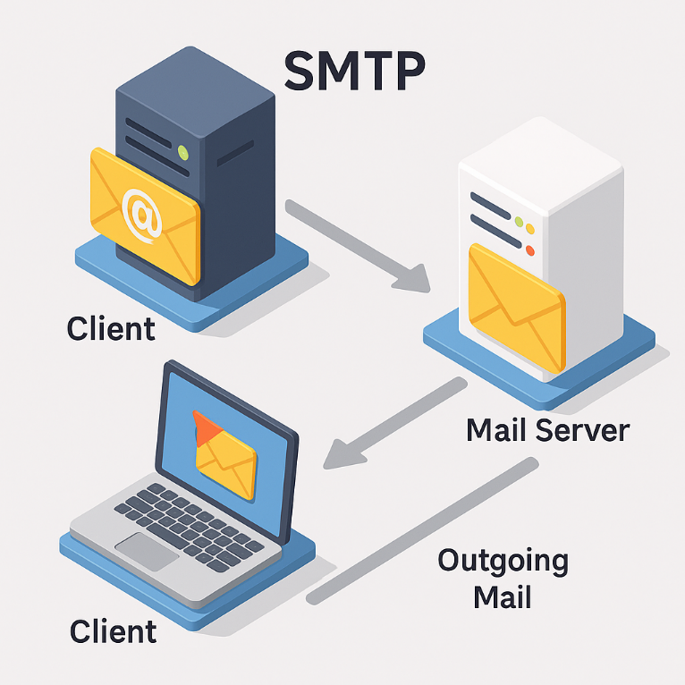

**Q20.DIFFEREENT BETWEEN OSI AND TCP/IP ?**

***OSI Model (Open Systems Interconnection)***

It is a **theoretical reference model** with **7 layers**.

Designed first to standardize networking functions.

Each layer is clearly separated with specific tasks.

***TCP/IP Model (Transmission Control Protocol/Internet Protocol)***

A **practical model** used in real-world networking, with **4 layers**.

Developed earlier and forms the basis of the modern internet.

Layers are more flexible and combined (e.g., Application layer includes OSI’s Application, Presentation, and Session).

**Q21 HTTP AND HTTPS**

HTTP (Hyper Text Transfer Protocol)

HTTP is a protocol used to **transfer web pages and data** between a web browser and a server.  
It is **not secure**, meaning data can be intercepted by third parties.

HTTPS (Hyper Text Transfer Protocol Secure)

HTTPS is the **secure version of HTTP** that uses encryption (SSL/TLS) to protect data.  
It ensures **data privacy and security**, especially on sensitive websites like banking or login pages.

**Q22 LOW LEVEL DESIGN AND HIGH LEVEL DESIGN ?**

Low-Level Design provides **detailed logic and internal structure** of each module. It includes class diagrams, data structures, algorithms, and functions.

High-Level Design is the **blueprint of the system architecture**. It shows how the system will be divided into modules and how those modules interact. It focuses on overall structure, technologies used, and major components.

**Q23 WHAT IS SRS?**

**Software Requirement Specification(SRS)**

**SRS** is a formal document that clearly defines the **functional and non-functional requirements** of a software system.

It acts as a **contract** between the client and the development team, explaining **what the software should do,** how it should perform, and any constraints or rules it must follow.

SRS tells the developers **exactly what to build** based on user needs and expectations.

## SDLC MCQ

## (bold text is the answer)

1.

A feasibility study using the SDLC model is conducted to

determine whether or not the project is technically possible

determine whether the proposal is financially viable

**Both a and b**

None of the above

2.

A well-documented life cycle model aids in the detection of what during the development phase?

Inconsistencies

Redundancies

Omission

**All of the above**

3.

How many lines of code does the Build & Fix Model suit for programming exercises?

**100-200**

300-400

600-700

Above 800+

4.

In which life cycle does regression testing play a significant role?

Waterfall model

**V model**

Iterative model

All of the above

5.

What determines if the project should go forward?

**feasibility assessment**

opportunity identification

system evaluation

program specification

6.

What is the most significant disadvantage of employing the RAD Model?

**Developers/designers that are highly specialized and skilled are required.**

Component reusability is improved.

Encourages client/customer input.

Increases component reusability.

7.

Which of the following developmental models is incremental?

Prototyping, V model, Agile

**Prototyping, RAD, Agile, RUP**

Prototyping, V model, RAD, Agile, RUP

**All of the above**

8.

Which of the following is an Agile development characteristic?

Shared code ownership

Test-Driven Development

Implement the simplest solution to meet today's problem

Continual feedback from customer

**All of the above**

9.

Which of the following steps in the SDLC framework are valid?

Requirement Gathering

Software Design

System Analysis

**All of the above**

10.

Who is in charge of system development, staffing, budgeting, and reporting, as well as ensuring that deadlines are met?

**Project managers**

Network engineers

Graphic designers

Systems analysts